1. Create ssh tunnel with Source as 6905 and Destination as 127.0.0.1:5901 via putty and login into the machine as ec2-user  
     
   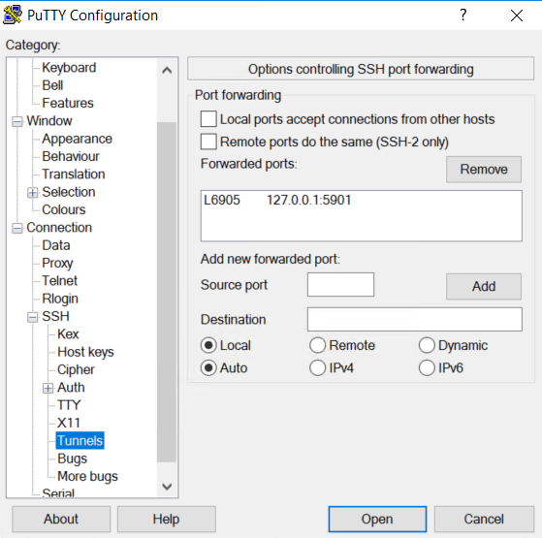
2. sudo yum install -y tigervnc-server.x86_64
3. sudo yum install -y tigervnc.x86_64
4. **sudo yum groups install -y "Server with GUI"** – This doesn’t work

{OR}

sudo yum group install -y "Server with GUI" --exclude=fwupdate-efi-12-5.0.3.el7.x86_64 -y --skip-broken

1. sudo su – oracle – Change to Oracle User
2. gconftool-2 -s -t bool /apps/gnome-screensaver/lock_enabled false
3. vncserver :1 -depth 16 -alwaysshared -geometry 1200x750 -s off

**vncpasswd** – Provide Password

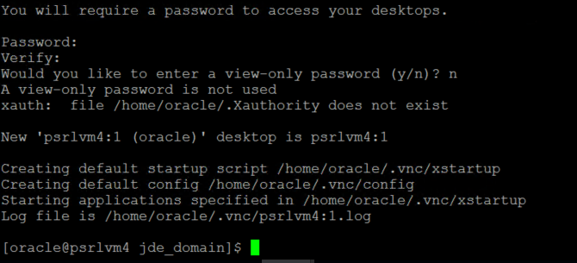

1. Download/Install VNC Viewer, located under (vncviewer.zip)
2. Open VNC Viewer on your local box and connect to 127.0.0.1:6905 and give above mentioned password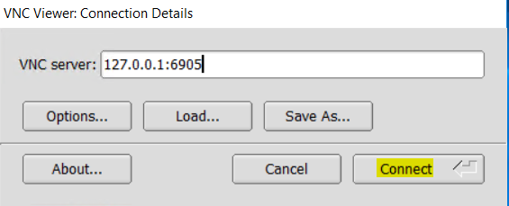

Click on Connect